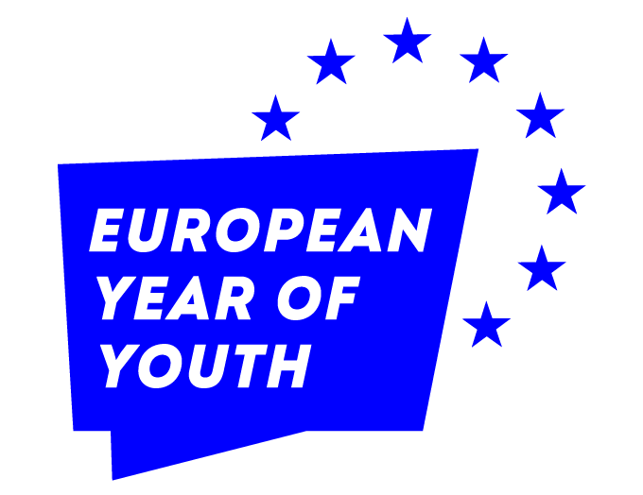

“Youth Inspiring the EU with their Ideas”
Application Guidelines
for Call for Ideas from Youth

Using the attached document, submit a 1-2 page proposal outlining your event or campaign ideas.

You may apply with more than one idea, but in such cases fill in and submit a separate application form for each idea.

Event or campaign ideas highlighting the following will be accepted:
  - Climate change and environment
  - Green transition
  - Digital transformation
  - Stronger economy, social justice and jobs
  - Active citizenship
  - Human rights
  - Education, culture, youth, and sports
  - Bicommunal ideas and actions in all of the above topics and more

The call for event or campaign ideas from youth is open to young people between the ages of 15 and 29.
The selected ideas for events and campaigns will be further developed and realised by the EUIP. The owners of the selected ideas may have the opportunity to join the EUIP team as volunteers (remunerated for their contribution) for the organisation of that very specific action (event or campaign).

For inspiration, please check
https://europa.eu/youth/home_en
https://europa.eu/next-generation-eu/index_en
https://europa.eu/youth/strategy/euyouthdialogue_en

Please submit your event or campaign ideas to info@abbilgi.eu by Monday, 21 February 2022, until 16:00 (Cyprus local time) using the application form below.

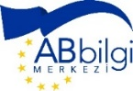
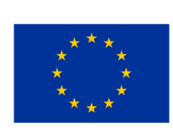
EU Infopoint is funded by the European Union.

“Youth Inspiring the EU with their Ideas”
Application Form
for Call for Ideas from Youth

*Submit your proposal in the table below. Maximum 2 pages
Title of the Action (event or campaign Idea)
Brief Summary of the proposed idea (including potential participants/ target groups)

Potential partner(s)/stakeholders in the implementation of the proposed idea

Proposed timeline of implementation

Details of the Applicant
Name & Surname
Date of Birth
Occupation /Current Work Status
If the applicant is a student – School
Email
Telephone
Address
If under 18
Name and Surname of the Parent(s)
Email of the parent(s)
Telephone of the parent(s)

EU Infopoint is funded by the European Union.

